Laporan praktikum MySQL
Mikhail 11 RPL

A. Table creation, Data Types & INSERT Statement.
1. Create Table Statement
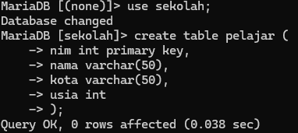
2. Insert Into Statement
3. Insert Into Multiple Rows
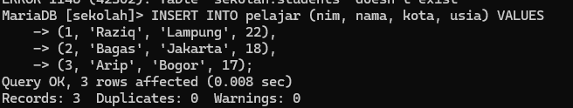
4. Insert Without Column List

B. UPDATE, DELETE, and INSERT Statement.
1. UPDATE Statement
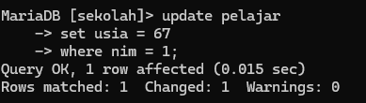
2. DELETE Statement
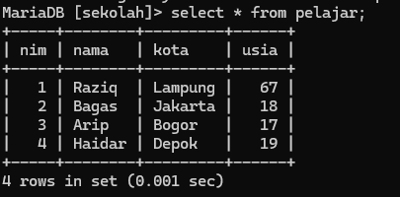
3. SELECT Statement
- Select All Columns
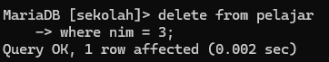
- Select Specific Column
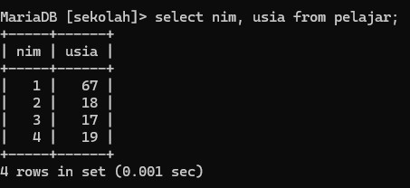

- Select With Conditions
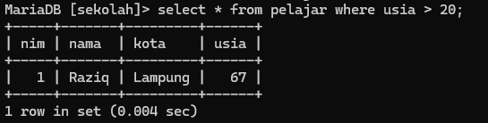
- Select With Order By
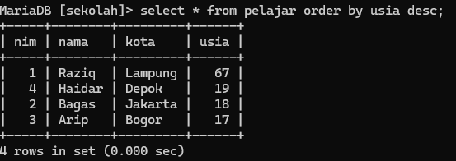

C. WHERE Clause, AND, OR, NOT Operators
1. WHERE Clause
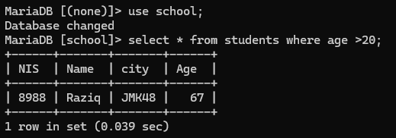
2. AND Operator
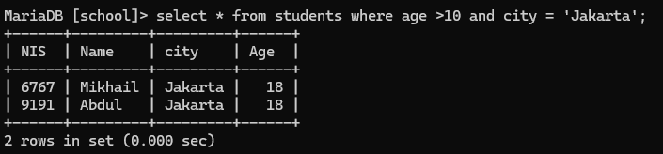
3. OR Operator
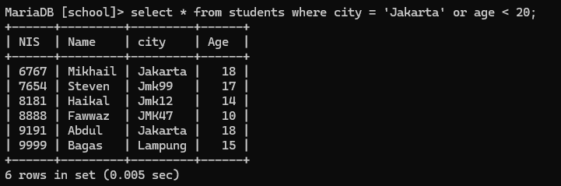
4. NOT Operator
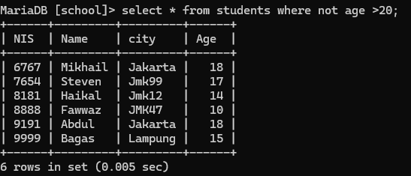
5. Combination of AND, OR, NOT
- AND + OR
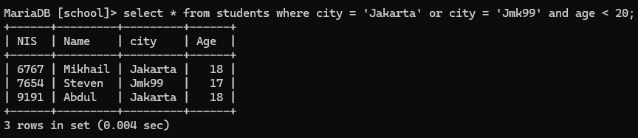
- NOT + AND
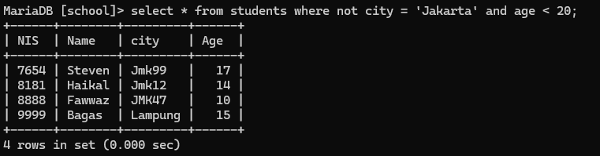
D. ORDER BY, DISTINCT, LIKE, BETWEEN, IN Operators
1. ORDER BY
- ASC
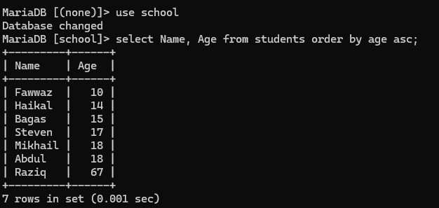
- DESC
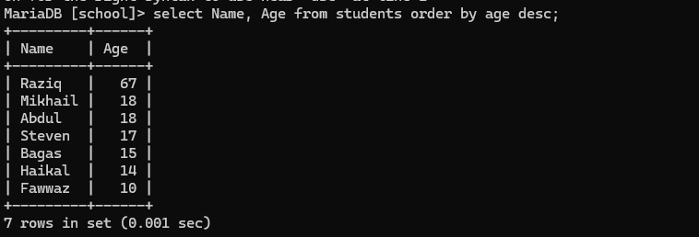
2. DISTINCT Keyword
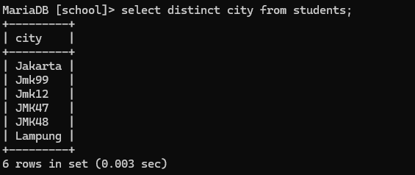
3. LIKE Operator
Names starting with ‘A’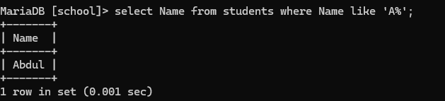
Names ending with ‘a’
Names having ‘a’ as second letter
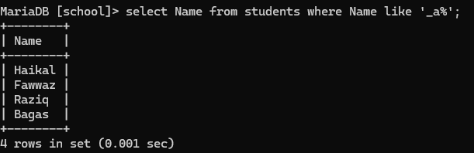
4. BETWEEN Operator
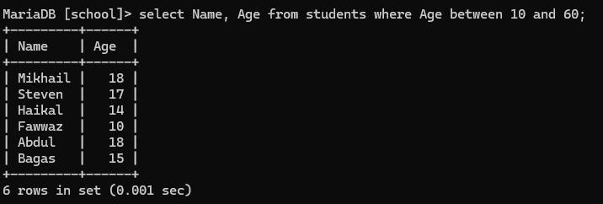
5. IN Operator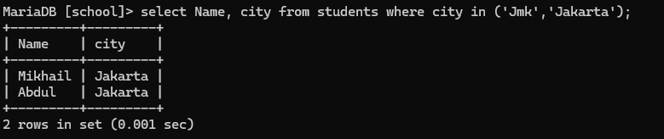

E. AGGREGATE FUNCTIONS (Group Functions)
1. COUNT ( ) 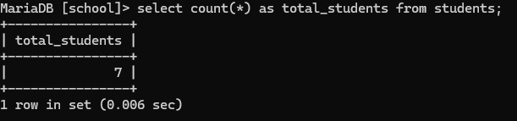
2. SUM ( ) 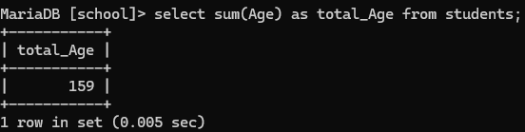
3. AVG ( ) 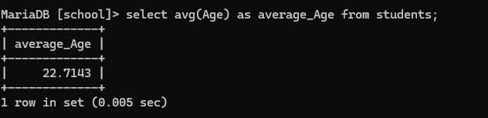
4. MIN ( ) 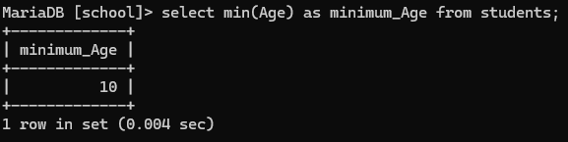
5. MAX ( ) 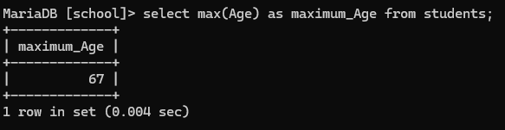
6. COUNT (DISTINCT) 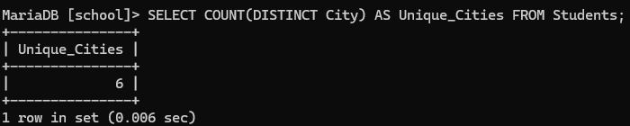

F. SQL JOINS
1. INNER JOIN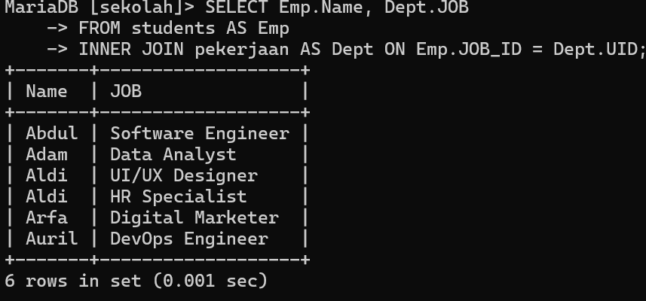
2. LEFT JOIN (LEFT OUTER JOIN) 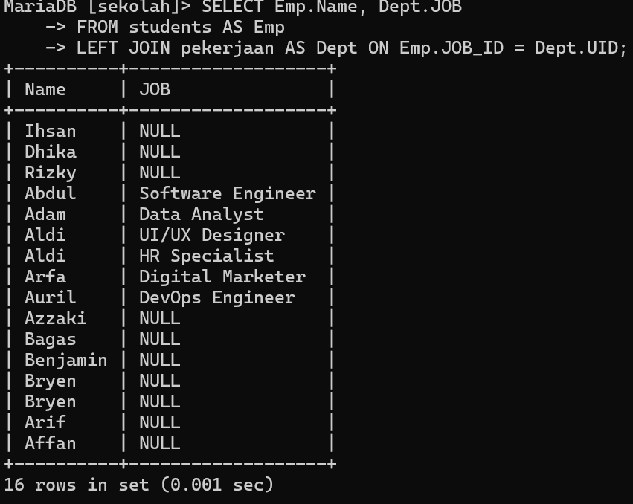
3. RIGHT JOIN (RIGHT OUTER JOIN) 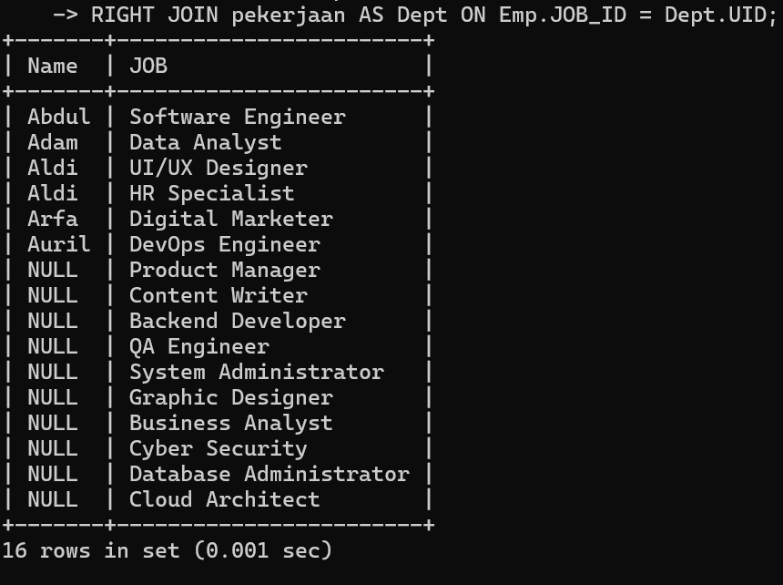
4. FULL JOIN (FULL OUTER JOIN) 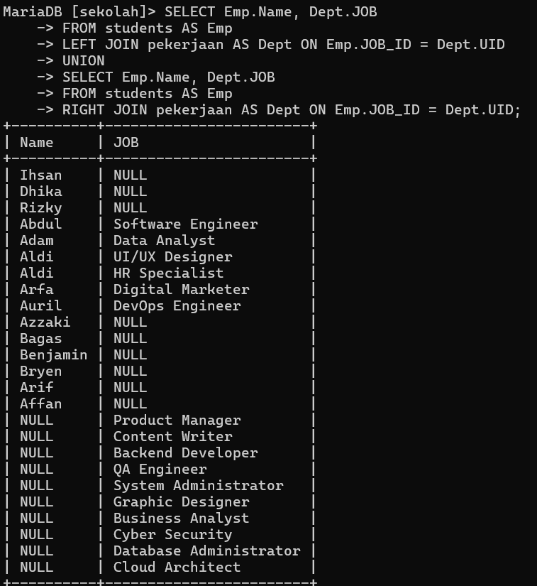
5. CROSS JOIN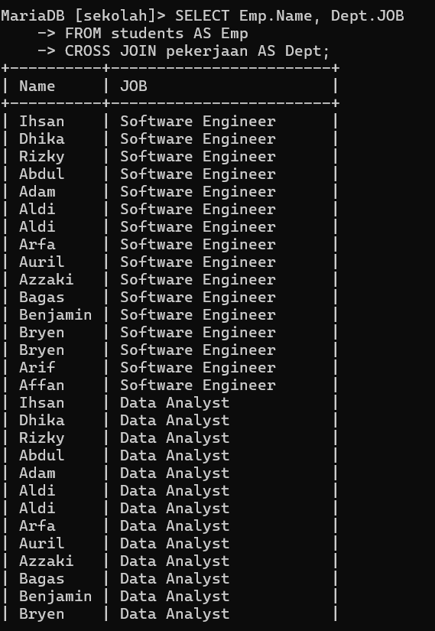
6. SELF JOIN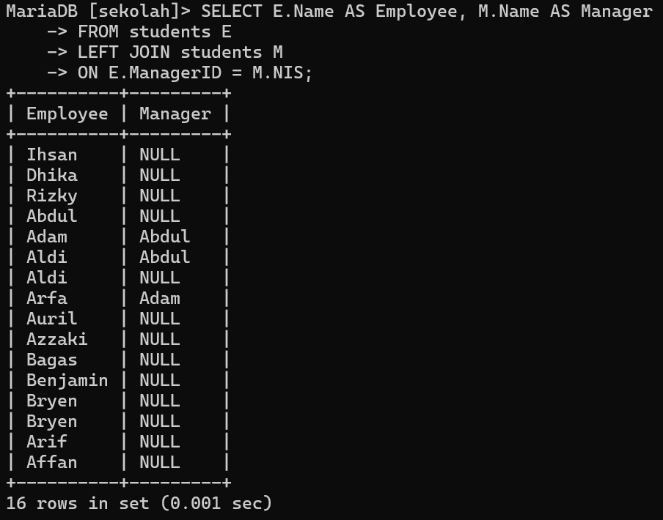

G. Subqueries (Nested queries)
1. SUBQUERY IN WHERE CLAUSE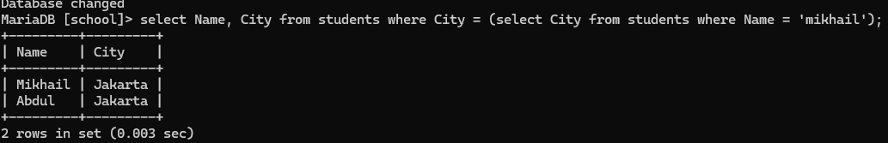
2. SUBQUERY IN FROM CLAUSE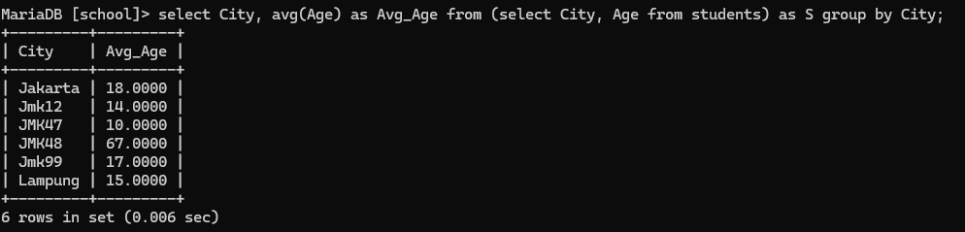
3. SUBQUERY WITH IN OPERATOR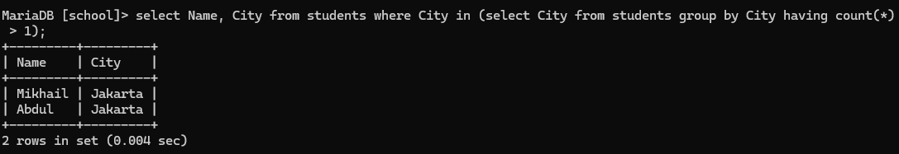
4. CORRELATED SUBQUERY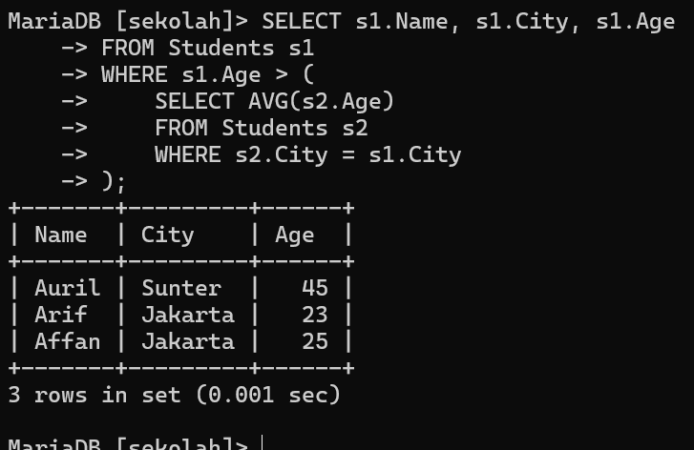
5. SUBQUERY WITH EXISTS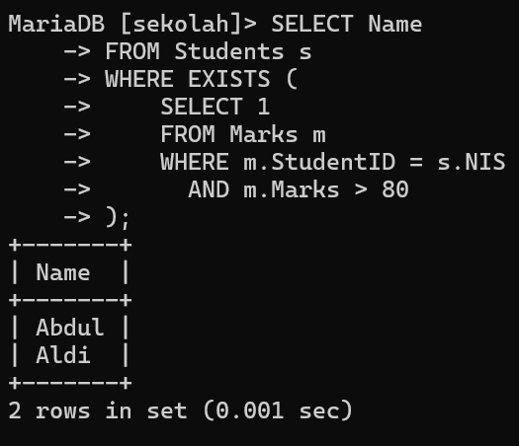
6. SUBQUERY WITH ANY / ALL